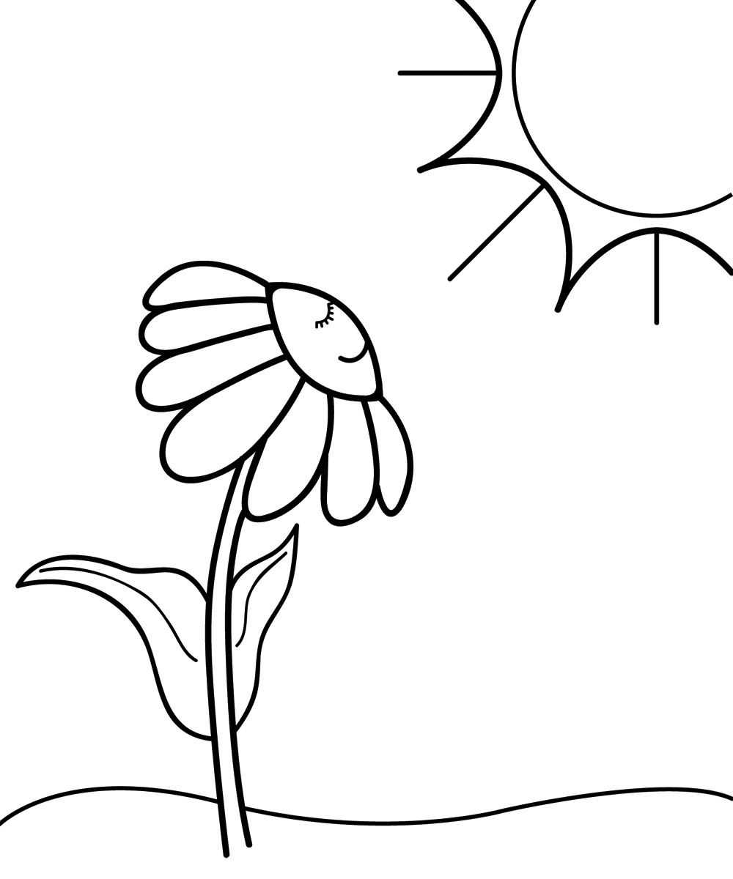Name: _________________

Period: ____ Date: _______

**Light and Dark**

*Four friends were talking about when plants carry out the process of photosynthesis and respiration. This is what they said:*

**Janet:** “Photosynthesis occurs in the light; plants don’t carry out the process of respiration”

**Calvin:** “Photosynthesis occurs when it is light; respiration occurs when it is dark.”

**Mika:** “Photosynthesis occurs when it is light; respiration occurs both when it is light and when it is dark.”

**Turner:** “Photosynthesis occurs both when it is light and when it is dark; respiration happens at night.”

*With whom do you agree the most?* _________________________________

*On the back explain why you agree with that person and not the others.*

Adapted from Page Keeley’s *Uncovering Student Ideas in Life Science,* VOL.1, NSTA press, 2011



Name: _________________

Period: ____ Date: _______

**Light and Dark**

*Four friends were talking about when plants carry out the process of photosynthesis and respiration. This is what they said:*

**Janet:** “Photosynthesis occurs in the light; plants don’t carry out the process of respiration”

**Calvin:** “Photosynthesis occurs when it is light; respiration occurs when it is dark.”

**Mika:** “Photosynthesis occurs when it is light; respiration occurs both when it is light and when it is dark.”

**Turner:** “Photosynthesis occurs both when it is light and when it is dark; respiration happens at night.”

*With whom do you agree the most? _________________________________*

*On the back explain why you agree with that person and not the others.*

Adapted from Page Keeley’s *Uncovering Student Ideas in Life Science,* VOL.1, NSTA press, 2011